MACH4METAL

metalworking machinery
Transito 21,
6909 DA BABBERICH, Netherlands
Tel. + 31 (0)316 – 247123

Bank No : 66.52.13.883
IBAN : NL33 INGB 0665 2138 83
BIC : INGBNL2A

MEBA BAND SAW 410 DG X 700 MM
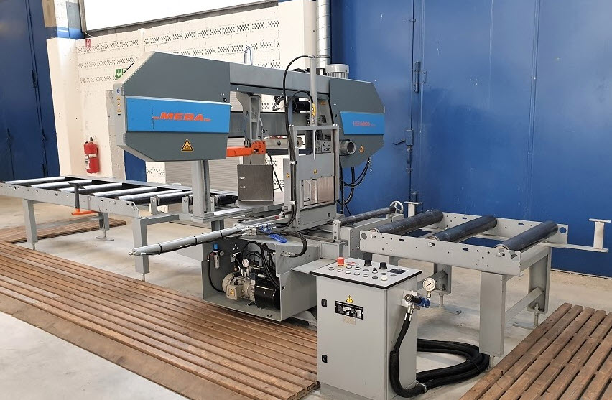
- Make : MEBA Germany
- Type : 410DG
- YOP : 2013 – 1500 H
- Serial : 65570

Cutting capacity 90 °
- Max. Ø : 410
- Max. height : 410
- Max. width : 700
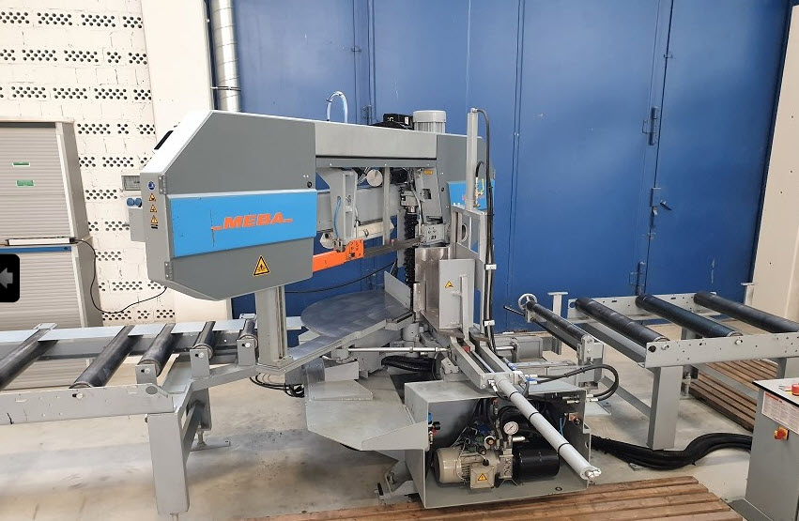
Cutting capacity R 45 °
- Max. Ø : 410
- Max. height : 410
- Max. width : 500

Cutting capacity L 45 °
- Max. Ø : 410
- Max. height : 410
- Max. width : 430
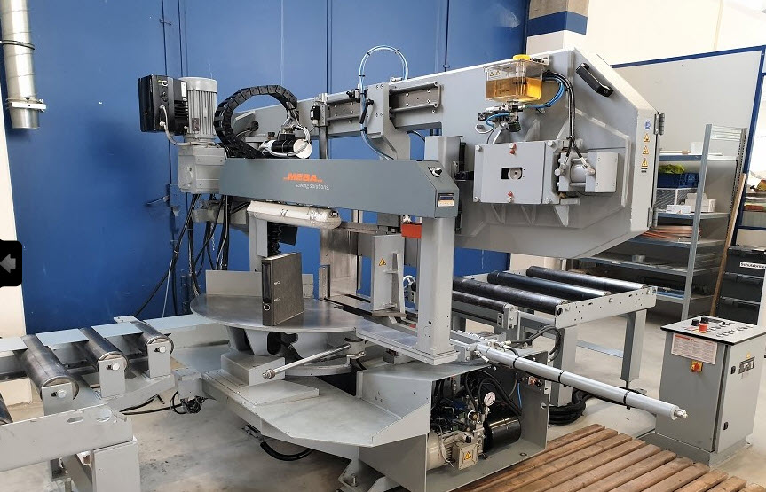
- Cutting speed : 15 – 150 M/Min
- Blade size : 5800 x 41 x 1,3

- Dimensions
- Length : 2.000
- Width : 3.000
- Height : 2.000
- Power : 5.5 kW

- Roller conveyor 3000 x 700 + 1000 x 700 mm
- Cutting pressure & feed control
- Hydraulic bundle tension
- Oil micro dispensing system
- Digital mitre display 0,1° for angle
- New EUR 50.000

Please Note: The above information has been obtained to the best of our ability and belief from, and from the manufacturers where possible. It is given in good faith, but its accuracy can not be guaranteed. Accordingly, it will not form a representation or constitute contractual terms. We advise you to check any vital deta

